  
  
  
INSTRUCTION MANUAL

V1.0

**Legal Bits!**  
  
The Habduino kit is sold as is with no guarantees of performance or operation.  
  
If you decide to use this product under a balloon it’s your responsibility to ensure you comply with the local legislation and laws regarding meteorological balloon launching and radio transmission in the air.   
  
The Radiometrix LMT2 434Mhz is NOT license exempt in the United States of America and does need a radio amateur license.

Use of APRS requires a radio amateur license in all countries and a number of countries don’t permit the airborne use of APRS under any circumstances.

The Habduino cannot do APRS without an addon Radiometrix HX1 module (See APRS Section).

The hardware design & code for Habduino is released under a Creative Commons License 3.0 Attribution-ShareAlike License :

See : <http://creativecommons.org/licenses/by-sa/3.0/>

It is YOUR responsibility to ensure this kit is used safely please review the safety section.  
  
The latest code is available here : <https://github.com/HABduino/HABduino>

**Kit Contents**

Habduino Sheild  
Battery Holder  
Active Patch Antenna  
RG174 to SMA pigtail  
  
**Introduction**  
  
Thanks for your purchase of the Habduino telemetry shield for Arduino. Habduino is compatible with the UKHAS telemetry formats and the APRS network where permitted.   
  
Habduino utilises the latest Ublox MAX7 GPS rated for altitudes > 18km, a 434Mhz TCXO equipped frequency agile radio transmitter and a step up power regulator. The code can also drive an optional HX1 simultaneously to provide both 434Mhz and APRS transmissions on 2 meters.   
  
  
  
  
  
  
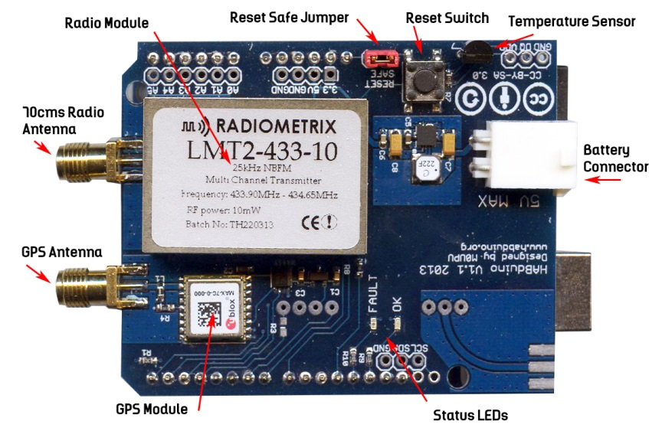

**UKHAS Guidelines**   
Source : http://ukhas.org.uk/guides:guidelines

This set of guidelines has been put together by members of UKHAS (United Kingdom High Altitude Society) as a recommendation of how to operate high altitude balloon flights safely. They are not legally binding rules however UKHAS do recommend that people follow them as they are based on years of experience in the UK and US. Launching a balloon is your own responsibility and while these rules won't protect you if something was to happen we'd expect that by following them you reduce the risk of any incidents.  
Generally permission from your local aviation authority must be obtained for a meteorological balloon flight; this will include a NOTAM for the launch site. Please see Legislation section.

Projects should aim to make their payload as light as possible both for safety but also as this will require less gas saving money and resources. Flights with payload weights below 1Kg should be the norm and payload weights above 2Kg are discouraged.

Keep within the ICAO regulations for light payloads:

* flight with one or more payload packages should have a combined mass of less than 4 kg.
* a force of less than 230 N is required to separate the suspended payload and parachute from the balloon. (See Note1)
* if any package is 2 kg or more the area density must be below 13 g per square centimetre. (See Note2)
* Payloads should have insulation surrounding the equipment both for maintaining temperature but also providing 'padding' on impact.
* Antenna elements that face down should be flexible - avoid metal rods.
* Before launching a balloon run computer modelled flight predictions (See Section Planning for a launch), postpone launch if there is a high chance of the payload landing in urban areas or near to airports. If the payload is predicated to pass through or near NOTAM'd airspace, Danger or Air Traffic Zones then discuss this with the operator of these areas.
* Always get the landowners permission before attempting to recover a payload.
* As there is a chance that your payload may not be recoverable strive to make it as environmentally friendly as possible.
* Seek help from more experienced UKHAS members when encountering an area outside your comfort zone.
* Follow local regulations when operating and storing compressed gases such as Helium or Hydrogen.

Note1: The force to be applied in a direction parallel to the suspension line.

Note2: The area density is determined by dividing the total mass in grams of the payload package by the area in square centimeters of its smallest surface.

**Gas Safety**

Compressed gas of any type can be dangerous and it is recommended you take advice from the supplier of the cylinders as to safety precautions. Gas cylinders are sometimes subject to local regulations with regards to transport and storage.

We suggest you review <http://www.hse.gov.uk/cdg/pdf/safusgc.pdf> for safe handling guidelines of all compressed gas.   
  
Should you choose to use Hydrogen additional safety precautions should be adhered too. It is outside of the scope of this instruction manual to discuss here but as always take safety precautions where necessary and review:

[http://ukhas.org.uk/guides:hydrogen?s[]=hydrogen](http://ukhas.org.uk/guides:hydrogen?s%5b%5d=hydrogen)

<http://arhab.org/pdfs/h2_safety_fsheet.pdf>

Getting Started

Hardware  
  
Insert the Habduino shield into your Arduino board. Please note:

**Never connect the USB and the external battery pack at the same time.**

Screw the GPS antenna firmly onto the GPS SMA connector.   
  
Although the GPS is connected via hardware serial the design means you can program the Arduino as normal without having to remove the shield.   
  
You don’t need an antenna on the radio to test but it may help. You can just insert a single core piece of wire 164mm long into the SMA socket for testing.

Plug the Arduino into your PC via the USB.

Getting Started

Software

The following guide assumes you already have the Arduino software installed. If not please visit <http://arduino.cc/en/Main/Software> and download the latest Arduino software.   
  
Downloading the Latest Firmware  
  
Visit <https://github.com/HABduino/HABduino> and click the “Download ZIP” button.  
Extract the ZIP file to somewhere  
Navigate to the extracted files and rename the folder called Software to habduino.

You should now be able to open the Arduino software and then File -> Open and navigate to the habdunino.ino file. If it advise it needs to be in its own folder this is fine but you will then need to close Arduino down and manually move the additional files ax25modem.h and sine_table.h into the the same folder as the habduino.ino file.

With Habduino.ino open scroll down to the line :  
  
char callsign[9] = "HABDUINO";  
  
Amend this to your choice of call sign of 8 characters or less.   
  
Pick a channel for the radio to work on (This will be replaced soon with direct frequency selection) by amending the following line :

#define LMT2_CHANNEL 15

Where :  
  
 0 = 433.896 16 = 433.871  
 1 = 433.946 17 = 433.921  
 2 = 433.996 18 = 433.971  
 3 = 434.046 19 = 434.021  
 4 = 434.096 20 = 434.071  
 5 = 434.146 21 = 434.121  
 6 = 434.196 22 = 434.171  
 7 = 434.246 23 = 434.221  
 8 = 434.296 24 = 434.271  
 9 = 434.346 25 = 434.321  
 10 = 434.396 26 = 434.371  
 11 = 434.446 27 = 434.421  
 12 = 434.496 28 = 434.471  
 13 = 434.546 29 = 434.521  
 14 = 434.596 30 = 434.571  
 15 = 434.646 31 = 434.621

For example 15 will put the transmission frequency around 434.646Mhz  
It is recommended you leave the baud rate ASCII and stop bits alone.   
  
Upload the code to the Arduino.

Operation  
  
Once uploaded at power on the board LED’s should flash rapidly, this is the initialisation period. After a short period the WARN LED should blink once a second until GPS lock as been achieved at which point the blinking red WARN LED should be replaced by a GREEN OK LED blinking.   
  
Occasionally the WARN LED may blink but quickly switch back to GREEN, this is ok.   
  
Once the module detects its above 1000 meters in altitude the LED’s will turn off entirely.   
  
Below 1000 meters the GPS module is in the more accurate pedestrian mode, above this the code will switch the module to flight mode to ensure it works at high altitude.   
  
It is recommended you remove the reset safe jumper to ensure no accidental resets.

To test tune your radio around the frequency,  
  
DL-FLdigi here..